PROJECT REPORT

Title: Password Strength Checker
Submitted by: Sanchita Sanjay Patil
Student Roll No: 43
Student Enrollment ID: 2403111016
Submitted to: Dr. R. S. Khamitkar
Department: Electronics and Computer Engineering
Date: _______________

1. Project Overview
This project is a Python-based application that checks the strength of a password entered by the user. It analyzes the password using multiple security rules such as length, use of uppercase and lowercase letters, digits, and special characters.
The application also calculates password entropy and provides a strength rating like Very Weak, Weak, Fair, Strong, or Very Strong.
Additionally, the system suggests a stronger password based on the user's input using intelligent transformations.

2. Problem Statement
With increasing cyber threats, weak passwords are one of the biggest security risks. Many users create simple and predictable passwords that can be easily guessed or cracked.
This project aims to develop a system that:
- Evaluates password strength
- Provides feedback to improve security
- Suggests strong alternative passwords

3. Technology Stack
- Programming Language: Python 3.x
- Libraries Used:
  - tkinter (GUI development)
  - re (Regular expressions)
  - math (Entropy calculation)
  - random, string (Password generation)

4. Implementation
The project works in the following steps:
- User enters a password in the GUI.
- The system checks:
  - Length of password
  - Uppercase and lowercase letters
  - Numbers and special characters
  - Repeated characters
  - Common patterns
- Password entropy is calculated using mathematical formula.
- Based on score and entropy, strength is classified.
- If password is weak:
  - A strong password suggestion is generated
- Results are displayed visually using:
  - Strength bar
  - Check indicators
  - Suggestions panel

5. Code Snippet
def calculate_entropy(password: str) -> float:
charset = 0
if re.search(r"[a-z]", password): charset += 26
if re.search(r"[A-Z]", password): charset += 26
if re.search(r"\d", password): charset += 10
if re.search(r"[^a-zA-Z\d]", password): charset += 32
return len(password) * math.log2(charset) if charset else 0

def analyze_password(password: str) -> dict:
checks = [
("At least 8 characters", len(password) >= 8),
("At least 12 characters", len(password) >= 12),
("Uppercase letter (A–Z)", bool(re.search(r"[A-Z]", password))),
("Lowercase letter (a–z)", bool(re.search(r"[a-z]", password))),
("Digit (0–9)", bool(re.search(r"\d", password))),
("Special character (!@#…)", bool(re.search(r"[^a-zA-Z\d]", password))),
]

score = sum(v for _, v in checks)
entropy = calculate_entropy(password)

if entropy > 60:
score += 1
elif entropy < 20:
score -= 1

return {
"score": score,
"entropy": entropy
}

6.Sample Test Cases
Input Password | Output Strength
12345 | Very Weak
password | Weak
Pass123 | Fair
Pass@1234 | Strong
P@ssW0rd!2024 | Very Strong

7. Challenges Faced
- Designing a user-friendly GUI using tkinter
- Implementing password entropy calculation
- Handling different password patterns
- Generating meaningful yet strong password suggestions
- Avoiding common and predictable sequences

8. Results and Observations
- The application successfully evaluates password strength.
- It provides real-time feedback to users.
- Suggested passwords are stronger and more secure.
- The system improves user awareness about password security.

9.Output

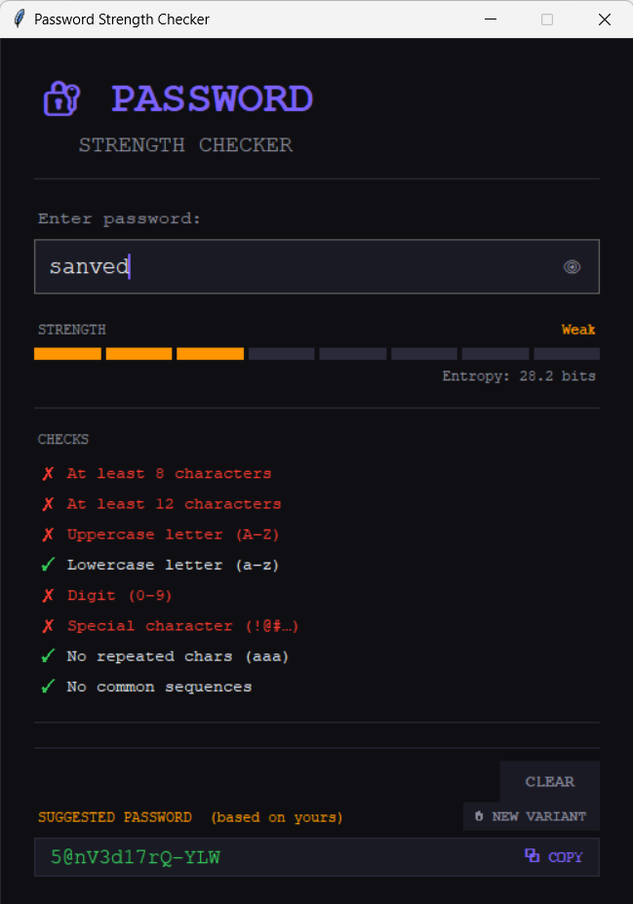

Project Submission
Repository Link: https://github.com/sanchita2186-pixel/Python-Project

9. Signatures
Student Signature: ___________________________

Guide Signature: _____________________________

Date: ______________

